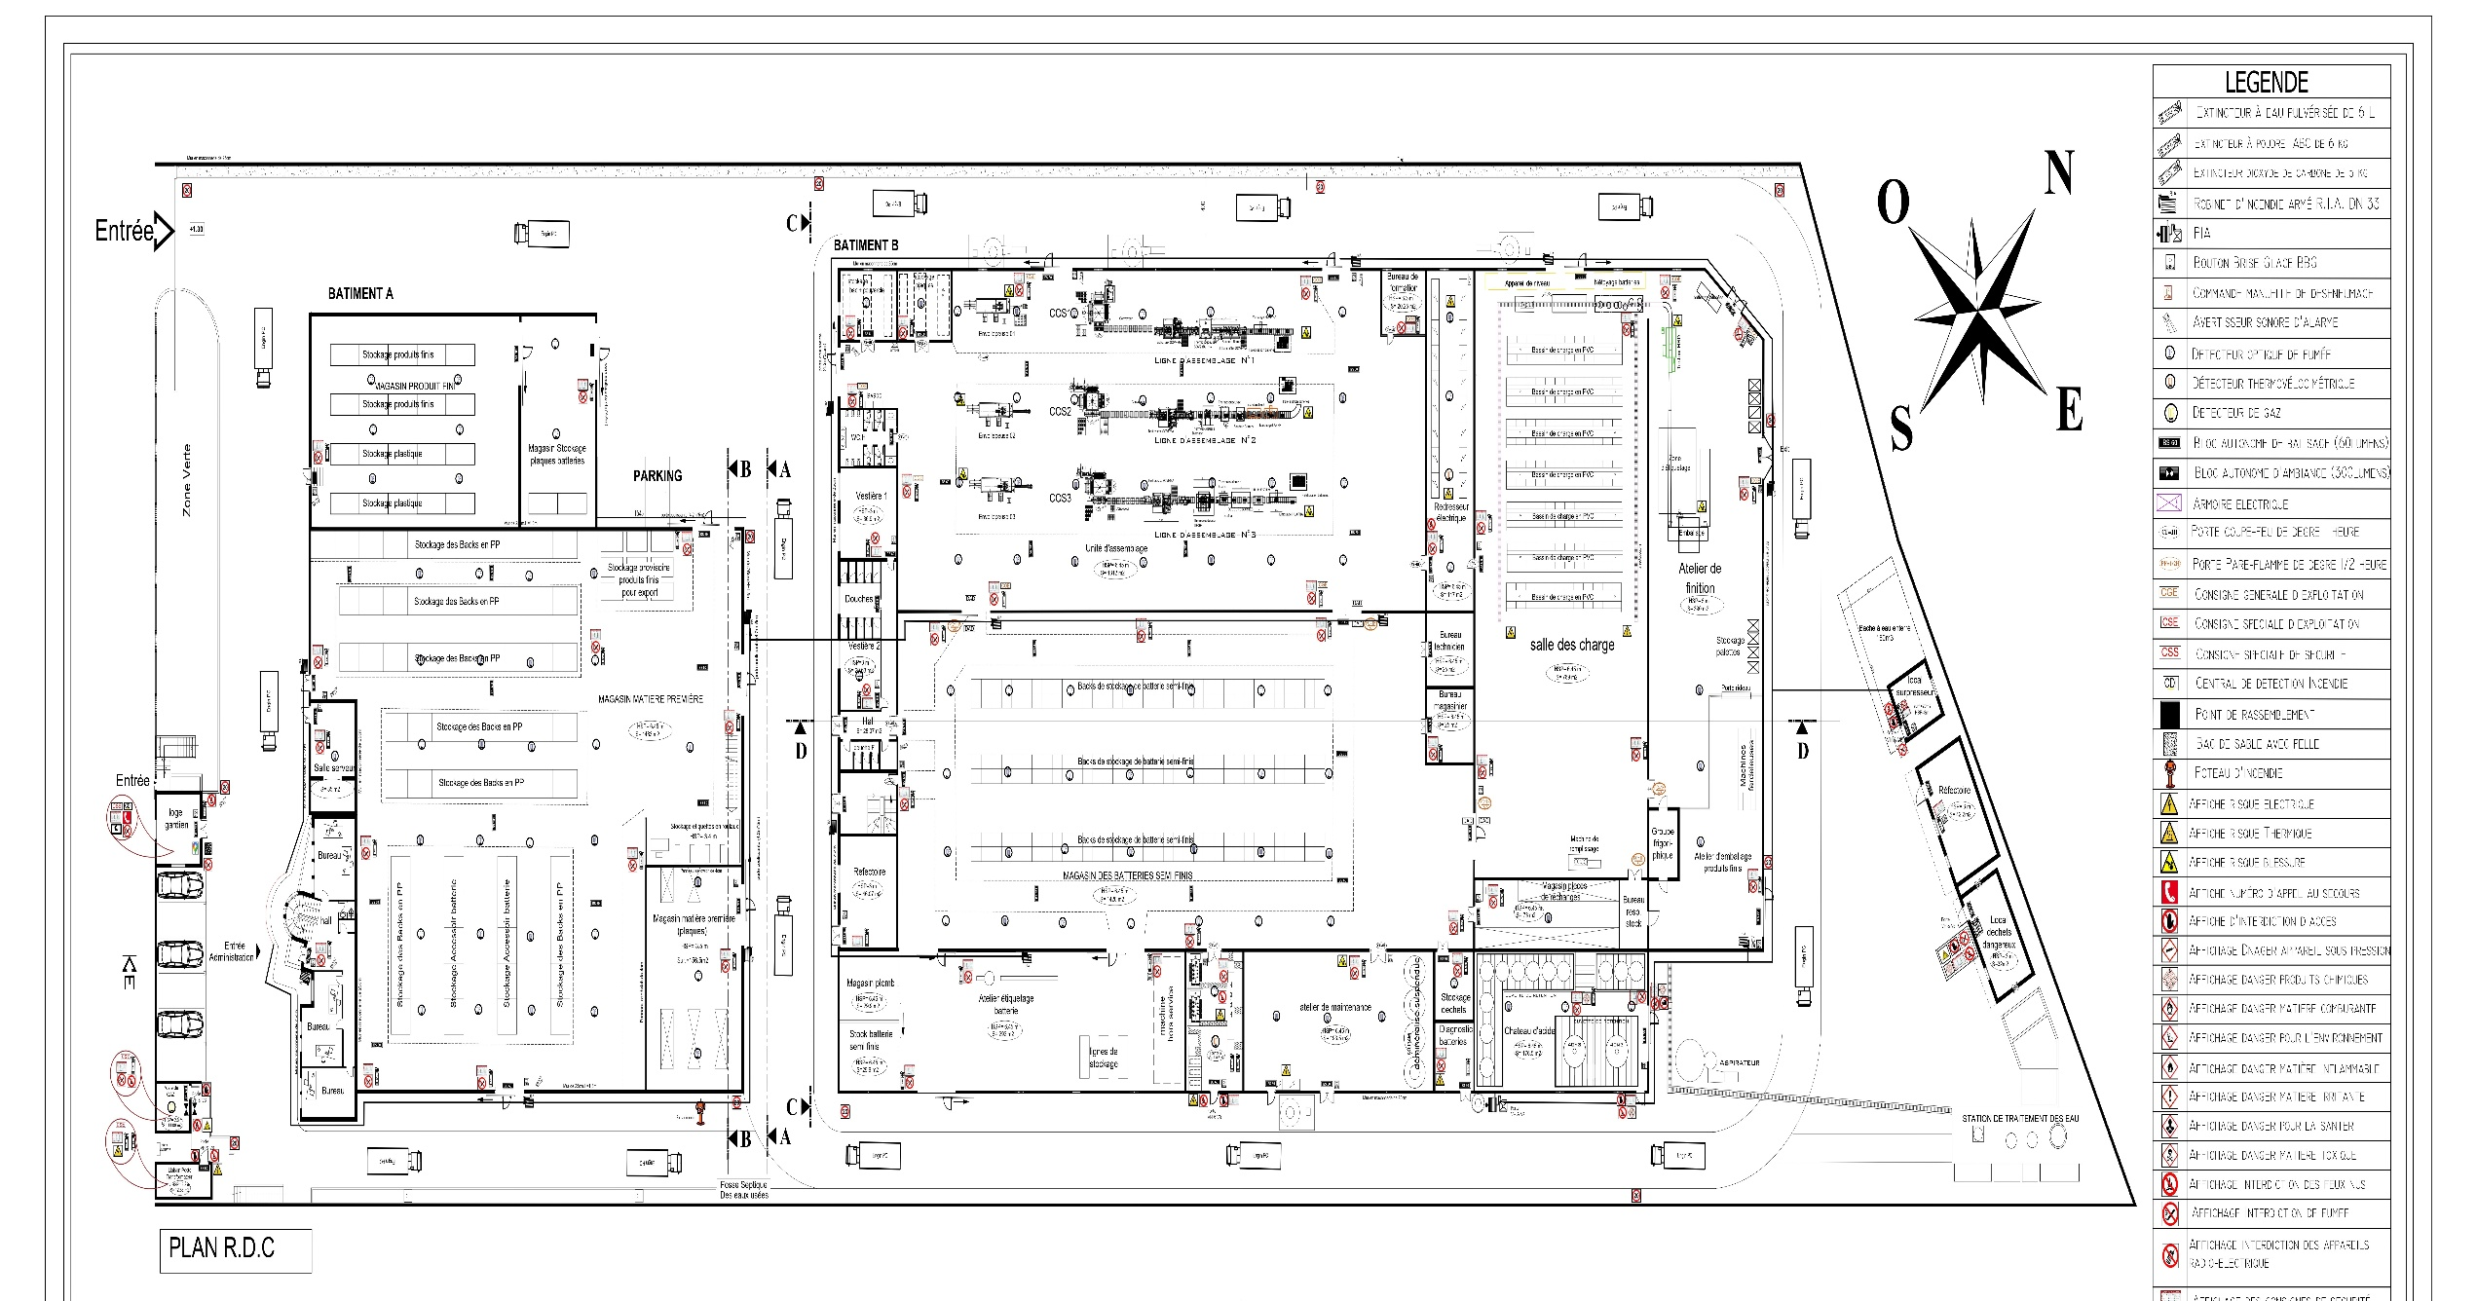
Camera IP19 (SNA1.1)
FINITION(SNA1.1)

MONTAGE TC
LIGNE 1 SC
Camera 01
Camera 01
NIVLEUSE
Camera IP24
FINITION

Camera IP28
Camera IP18 (SNA1.1)

Camera IP22(SNA1.1)
Camera IP7
Camera IP11
MAGASIN_PSF
MAGASIN_PF
MONTAGE L123
PDR
Camera IP4

COS3
MAGASIN_PSF
Camera IP2
CHATEAU ACIDE
MAGASIN EXPORT SECHE
Camera IP3
Camera IP17
Camera IP2
Camera IP14
Camera IP1
Camera IP6
Camera IP1
ELBACK TEC-MAX
CHARGE
FINITION
Camera IP29
Camera IP26
EXPORT SECHE
Camera IP27
Camera IP12
Camera IP5
Cos3(SNA1.1)
Camera IP3
Camera IP13
Camera IP10
Camera IP5
Camera IP4
Camera IP30
Camera IP6
Camera IP16
Camera IP32
Camera IP7
Camera IP8
Camera IP15
LIGNE 3 SC
Camera IP31
Camera 01
Camera IP20 (SNA1.1)
Camera interne (SNA1.2) : 38

Camera externe (SNA1.1) : 19

