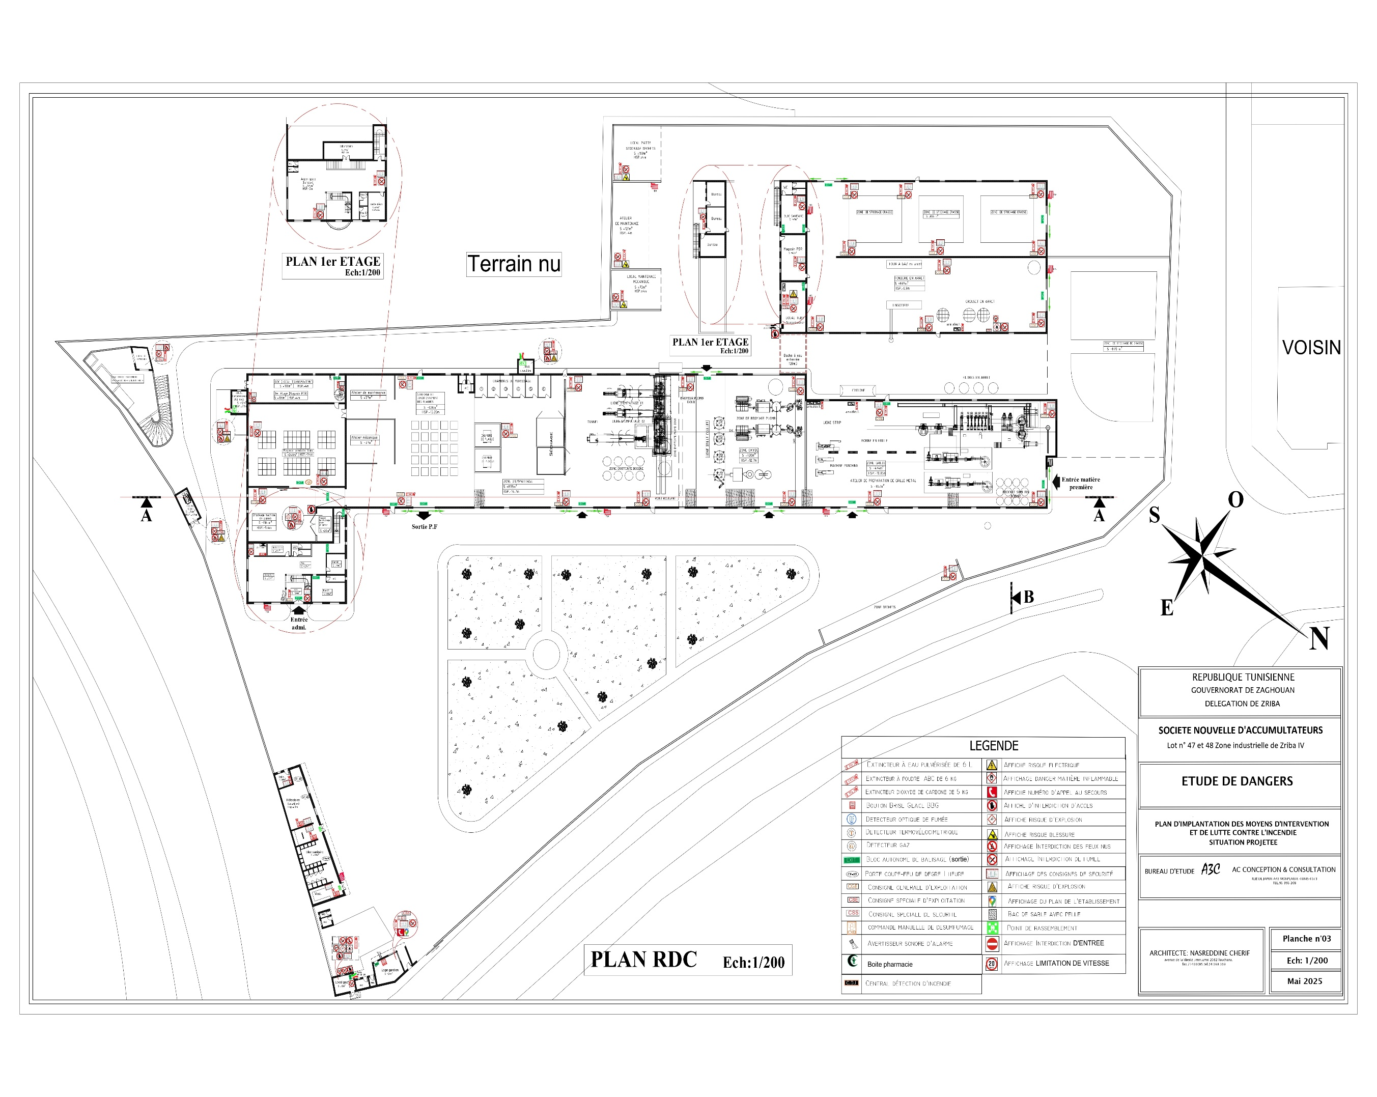
IP Camera2
Camera 01
IP Camera31/32

Atelier STRIP
IP Camera10
IP Camera17
IP Camera19
IP Camera8
IP Camera13
IP Camera12
IP Camera14
IP Camera16

ANNULER
IP Camera16
IP Camera18
Camera 01
IP Camera11

IP Camera14
IP Camera15
IP Camera7
Camera Interne (SNA2.2) : 27
Camera Externe (SNA2.1) : 21
IP Camera5
Camera 01
IP Camera2
Camera 01
IP Camera01
Camera 01
IP Camera6
IP Camera21
IP Camera20
IP Camera11
IP Camera4
IP Camera5
IP Camera1
IP Camera9
IP Camera10
IP Camera6
Camera 01
Camera 01
IP Camera4
Camera 01
IP Camera13
IP Camera3
Camera 01
Camera 01
Camera 01
IP Camera23
IP Camera22
Camera 01
Camera 01

